

Operating Systems

Samjhana Dahal
Bsc (Hons) Computer Science with Artificial Intelligence
Softwarica College of IT and E-commerce ST5003CMD
Operating Systems, Security, and Networks
Rupak Rajbanshi
13th September 2026

Figure 1: Computer System Layers 3
Figure 2: virtualization 4

- What is an Operating System? Provide an example.

An Operating System (OS) is system software that manages computer hardware and software.
Example: Windows, Linux, Android.
2. What are the three main purposes of an Operating System?
- Resource Management – Manages CPU, memory, and storage.
- User Interface – Allows users to interact with the computer.
- Program Management – Manages and runs programs.
3. Name three types of Operating Systems and give one example for each.
- Batch OS – IBM OS/360
- Real-Time OS – VxWorks
- Distributed OS – Plan 9

4. What is the Kernel? How is it different from the full Operating System?
The Kernel is the core part of an OS that manages hardware and system resources.
Difference: The Kernel is the core, while the full OS includes the kernel plus other system services and user interfaces.
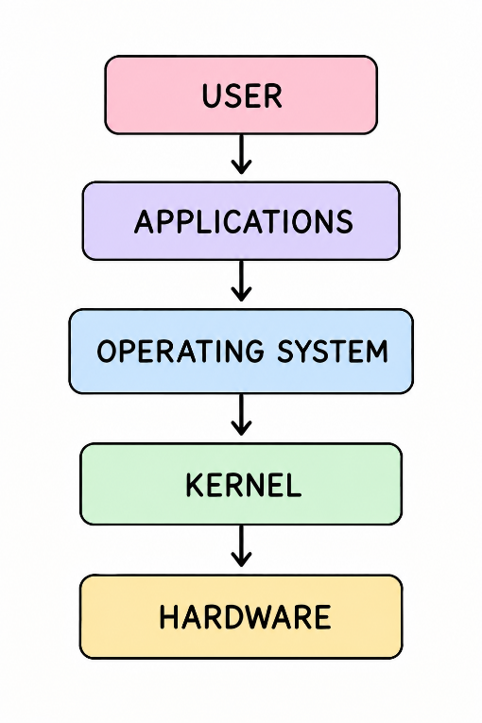
Figure 1: Computer System Layers

5. What is a Process? How is it different from a Program?
A program is a set of instructions stored on a computer, while a process is a program that is currently running.
Example: Chrome installed = Program; Chrome running = Process.

6. What is Virtualization? Name one benefit of using virtual machines.
Virtualization allows one physical computer to run multiple virtual computers or operating systems.
Benefit: It allows different operating systems to run on the same physical machine.
Example: Running Linux on Windows using VirtualBox.
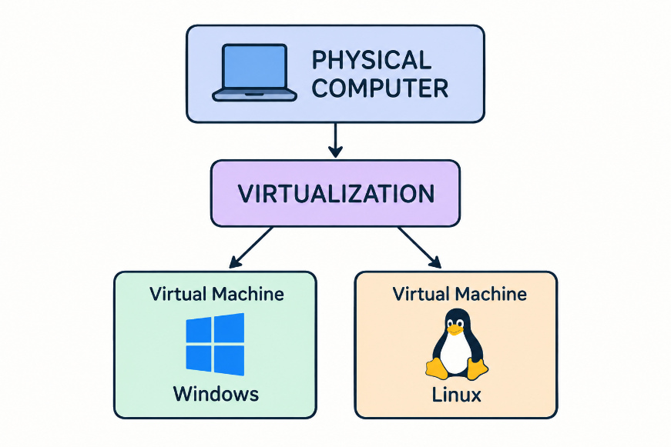
Figure 2: virtualization

7. Name two computing environments where Operating Systems are used.
- Desktop Computers – Windows, Linux
- Mobile Devices – Android, iOS

